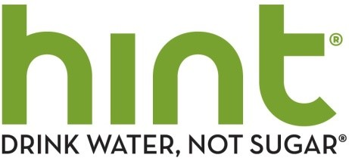

ASSIGNMENT: hint water customer engagement representative
LOCATION: san francisco, ca

WHAT’S THE JOB?
Join our team! Play a huge role in growing our online store + connecting with our die-hard hint water fans and making them happy.

hint water provides top tier customer service. This includes answering questions about each of our brands, directing contact requests to the right team member, making and returning customer calls, and handling questions, regarding individual orders, subscription changes, order changes, and payment information. You will also be engaging customers online via the chat channel.

You’ll be working directly with our Customer Engagement Manager and key players on our direct to consumer team. This is a key role, dealing with fan satisfaction and our VIP customers, while spreading the philosophy of hint – fun, healthy, friendly.

WHO ARE YOU?
YOU are a fun positive people-person who digs the healthy lifestyle. You know the hint brand well, have ample customer service experience, and are extremely detail oriented. You know how to create systems, and problem solve – well. You’re compassionate, understanding, and very patient. You work well with all personality types and view customer service as a foundation-building necessity of a company.

You also can work well alone, know when to ask for help, and aren’t afraid of voicing your thoughts. We’re looking for smart folks who want to make a difference.

Notes:
- Flexibility to work remotely, but needs to be based in the San Francisco Bay Area for in-person meetings
- Need to be available 2 hours on Saturday

WHO ARE WE?
hint water is a refreshing alternative to sodas, juice and other sweetened drinks and it tastes great! We are on a mission to help the world live a healthy lifestyle. Apparently we are on to something -- our water is popping up in all sorts of places such as Time Magazine, the Academy Awards, on Grey’s Anatomy and in the hands of fans such as John Legend, Steven Spielberg and Charlize Theron.

Founded in 2005 by former AOL Executive, serial entrepreneur and mom, Kara Goldin, hint, hint fizz®, and hint kick® have over 16 delicious flavors. hint can be purchased online at www.drinkhint.com, Amazon.com, and grocery stores across the country!

The idea behind hint is simple: No sugar, no diet sweeteners. EVER. Just great taste in a cool, refreshing drink.

Requirements:

- Ability to work Saturday for 2 hours (flexible)
- Ability to work 1pm-5 pm Monday - Friday
- Ability to make and answer phone calls during working hours
- Fun, friendly and personable + patient & compassionate
- Interest in a healthy lifestyle
- Frequently checks emails & responds during work hours
- Excellent communication skills
- Excellent organizational skills
- People would describe you as a “people person”
- Eager to learn the hint brand + product – inside & out
- Bachelors degree preferred, or customer service experience
- Experience with providing customer engagement via online chat a bonus

Interested? We thought you might be…

If you think you may be a match, send an email to karin@drinkhint.com, subject line “customer engagement representative”. Include your resume; let us know why you’re interested, and anything else you think might impress us!

